

FACULTY OF INFORMATION TECHNOLOGY AND ELECTRICAL ENGINEERING

**Haoyu Chen**

**A technical report of NLP project: An automatic real-time text summarizer application with three core methods**

Course report

Degree Programme in Computer Science and Engineering

November 2017

**Chen H(2017)** **A technical report of NLP project: An automatic real-time text summarizer application with three core methods.** University of Oulu, Degree Programme in Computer Science and Engineering.

Abstract

**An automatic real-time text summarizer application with three core methods is developed during this course. A detailed technical description of this application is given in this report. Automatic summarizers are text processors that can extract the valuable information of a given text with a compressed version. By implementing three kinds of core information extraction methods, a demo of text summarizer is developed in Python. Three core methods are Latent Semantic Analysis(LSA)&Text Rank(TR), Named Entity Recognition(NER) and Rapid Automatic Keyword Extraction(RAKE) respectively. Implementations of two sets of protocols are achieved for local text file and text content of website. It is also able to process multi-language as English and Chinese. We also achieve a real-time image search method for keywords in the given text, which can display the core topic of the given text. The method is simple to implement, and proved to be effective. The summary methods, LSA&TR, NER and RAKE are evaluated on several popular fictions and DUC2003 database with N-Rouge method. Experimental results show that we are able to achieve text summarization with satisfied accuracy with these three models. The application we developed of the text summarizer has a user-friend interface and easy-to-use. The UI is developed with Tkinter, which is capable to different platform including Windows, OS, Linux etc.**

**Keywords:** **NLP, summarizer, real-time, multi-language, LSA, TR, NER, RAKE, Tkinter, N-rouge**

Table of contents

Abstract 7

Table of contents 8

Foreword 9

Abbreviations 10

1. INTRODUCTION 11

1.1. Background 11

1.2. Project Objectives 12

1.3. Structure of This Report 12

2. Introduction 13

2.1. Natural Language Processing 13

2.2. Textual Mining 13

2.3. Automatic Text Summarization 13

2.4. Related Work 14

2.4.1. Main NLP toolkits introduction 14

2.4.2. Summary related NLP Toolkits 15

3. TEXTUAL SUMMARIZATION WITH LSA&TR 17

3.1. LSA introduction 17

3.2. Page Rank introduction 18

3.3. Implement Setup and Procedure 20

3.3.1. LSA 20

3.3.2. PageRank/TextRank 20

3.3.3. Sentence selection 20

4. TEXTUAL SUMMARIZATION WITH NER 21

4.1. Named Entities Recognition 21

4.2. Implementation with NLTK 21

4.3. Named Entities Recognition 22

4.4. Implementation with NLTK 22

5. TEXTUAL SUMMARIZATION WITH RAKE 23

5.1. Keywords extraction 23

5.2. Keywords extraction algorithm 23

5.3. Keyword extraction with Python using RAKE 24

5.4. Implementation RAKE in Python 24

6. A summarizer Application 26

7. EXPERIMENTAL RESULTS AND DISCUSSION 27

7.1. Experiments 27

7.2. Evaluation Methods 28

7.3. Experimental Results 29

7.4. Results Analysis and Discussion 31

8. Conclusion 33

9. REFERENCES 34

Foreword

This project was completed during the course Natural Language Processing at the University of Oulu, Finland. First, we would like to give our regards and thanks to professor Mourad Oussalah for his effort in teaching and show us compelling field NLP. We benefit a lot from this NLP course and appreciate for his detailed and patient teaching.

We would also like to thank the teach assistants Youngsu Dong and Abhinay Pandya. They gave as a very detailed description of the project.

Finally, we would also appreciate this city, Oulu. It is a pretty peaceful and suitable place to focus on the study.

Oulu, 20.11.2017

Haoyu Chen

Abbreviations

LSA

TR

NER

RAKE

NLP

HMM Hidden Markov Model

# INTRODUCTION

## Background

In the past two decades, we have experienced an exponential growth in the availability of electronic textual information for inquiry. The best example of the hugest and most extensive collection of files is the Internet, as its millions of web page files. Now, it's not uncommon to search thousands of web pages using Google and the electronic textual files, but the user must decide if a document will be interesting by themselves. Therefore, each file needs to be downloaded and read until the user finds a satisfactory one. This is an unnecessary and time-consuming routine. Therefore, it is essential to develop an automated method of detecting the most relevant content from the source file so that it appears as a summary. In addition, there are some scenarios where it is useful to build such a snippet automatically. Other examples include automatically building news summaries or e-mail summaries to send as text messages to mobile devices; providing summaries of information for government officials, business people, researchers, etc., as well as web page snippets on mobile device screens. These examples show that the method of text summarization is more suitable for language and dominance of independence.

Text summarization try to produce an abridged version of a text that contains information that is important or relevant to a user. Summarization is part of machine learning and data mining. The main idea of summarization is to find a subset of data which contains the “information” of the entire set. Such techniques are widely used in industry today. Search engines are an example.

Automatic Text Summarization (ATS) is an active research area that deals with single- and multi-document summarization tasks. In single-document summarization, the summary of only one document is built, while in multi-document summarization the summary of a whole collection of documents (such as all today’s news or all search results for a query) is built []. While our applications apply to either case, in this work we have experimented both ways.

Summarization methods can be classified into abstractive and extractive summarization [1].

An abstractive summary is an arbitrary text that describes the contexts of the source document. Abstractive summarization process consists of “understanding” the original text and “re-telling” it in fewer words. While this may seem the best way to construct a summary (and this is how human beings do it), in real-life setting immaturity of the corresponding linguistic technology for text analysis and generation currently renders such methods practically infeasible.

An extractive summary, in contrast, is composed with a selection of sentences (or phrases, paragraphs, etc.) from the original text, usually presented to the user in the same order—i.e., a copy of the source text with most sentences omitted. An extractive summarization method only decides, for each sentence, whether or not it will be included in the summary.

In our application, we will implement both these two kinds of summarizer. For LSA and RAKE summarizers, we achieve the extractive summary, for NER summarizers, we realize the abstractive summary.

Based on this situation, we propose a gesture dataset that contains gestures performed by participants all in spontaneous states, called MG dataset, and summarize the properties of MG dataset that differ from the gestures designed beforehand. To the fact that gesture recognitions tend to use high-level features, while Hinton and others [46] sparked a resurgence of neural networks and deep neural architectures which have been proved to be an effective approach for high-level features extracting from a set number of input samples. Then we implement two kinds of neutral networks as the DBN and 3DCNN to the dataset to test their performances on the MG dataset. We also improve these two architectures by taking the properties of MG into account to get a better result.

## Project Objectives

Our first target is finding theoretical basis for both those three methods, LSA, NER and Rake. A detailed explanation of the theoretical principles for these three methods are given. Based on the analysis, our second target is to implement the three methods with a satisfied accuracy. Our last target is to design a functional application with these three summarizer as the core algorithms.

## Structure of This Report

The structure of this report is as follows. Chapter 2 introduces the NLP Toolkits that we used in this project, and the related preprocesses done on the text, including stemming, format converting and tokenization, etc. In Chapter 3, we present the basic principles of LSA and TR, as well as how LSA and TR are implemented for textual summarization. In Chapter 4, we present the basic principles of NER, as well as how it is implemented for textual summarization. Next, in Chapter 5 we present a detailed method using the RAKE strategy to realize textual summarizer. Chapter 6 provides detailed implemental steps for the automatic textual summarizer. Particularly, several practical functions are realized such as multi-language, real-time web-search and etc. Chapter 7 provides detailed experimental result on the DUC2003 database. Then, the experimental results are analyzed. These three methods are compared in the discussion. Chapter 8 provides some concluding remarks of the whole work in this project and directions for future work.

# Introduction

The aim of this chapter is to give a description and a definition of Automatic Text Summarization. We introduce the reader to some basic terms given about NLP and ATS. Then, a brief introduction of NLP toolkits settled by predecessors will be given, and we will introduce NLP toolkits APIs related to our work.

## Natural Language Processing

Natural Language Processing is the unique combination of Artificial Intelligence and Computational Linguistics. The main idea in NLP is the make computers understand human languages. NLP tries to achieve the classic case of human – computer interaction as such of human – human interaction. This has been a very challenging problem of computer science as it requires handling various concepts of natural language understanding [5]. NLP systems used to be hard-coded because of complexity and numerous rules of human language. This hindered the growth in research of NLP. But with the increased advancements in Machine Learning techniques, the NLP systems are 4 trained to learn the essentials of human language and thus making towards perfection. Parts of speech tagging process are one example of NLP system, which assigns the specific POS to the word. Decision tree, Hidden Markov Model, Statistical model is some machine learning techniques that are fruitful in training NLP systems.

## Textual Mining

Text Data mining is the process of getting patterns from text data. Bag of words and NLP based techniques are two prominent text-mining approaches. Bag of words won’t deal with the morphological or semantic structure of input text, whereas NLP based techniques deal with some of morphological structure of text. The basic idea behind text mining is similar to that of data mining. Structuring the data, deriving patterns, evaluating and presenting the patterns are the common steps of text mining.

## Automatic Text Summarization

Automatic Text Summarization is the process of distilling the most important information from a source (or sources) to produce an abridged version for a particular user and task [7]. The goal of this process is to obtain at a summary, which is very short in length without loosing the ideology of the document.

With the increasing problem of Information Overload and data availability on Internet, the quality of results of search query of user is reducing. This made the need of research in the area of summarization very prominent. As NLP is still in evolving process, Information Retrieval based Automatic Text Summarization gained prominence. IR based summarization techniques mostly rely and work at word level. With the advancements in Machine Learning and graph theory techniques, research in summarization has escalated to sentence level. Broadly, Text Summarization can be classified as two approaches, Extractive and Abstractive.

**Extraction based Summarization**

The idea behind extraction-based summarization is to select a subset of sentences from the document and represent as summary. The sentences to be selected are based on word level features like frequency, key phrases etc. In some cases, Extractive summaries can be just a set of key phrases. Those types of summaries are predominant in news domains.

**Abstraction based Summarization**

In Abstractive based summarization, instead of selecting sentences or key phrases, the document is re-phrased to create a summary. This type of summarization builds internal semantic structures and uses NLP techniques to re-phrase the document. Although the ultimate goal of Automatic Text Summarization is to obtain abstractive summary that is very similar to human produced summary, lack of advancements in Natural Language processing and Understanding has hindered its research. Present day research is based on extractive based summarization systems to get at greater recall for summary with respect to original document.

## Related Work

Among numerous related toolkits in natural language processing, there have been APIs for both text documents and web pages processing. With various NLP toolkits provided online, the implementation of our project have involved practical functions. Here we will introduce two main toolkits of natural language processing these days as well as three summary toolkits we used.

### Main NLP toolkits introduction

After doing a wide survey of the NLP toolkits related to textual processing, we summarized several popular toolkits in this field.

In the following sections, two well-known NLP toolkits for textual processing will be introduced as well as their properties.

**NLTK toolkit**

The Natural Language Toolkit, or more commonly NLTK, is a suite of libraries and programs for symbolic and statistical natural language processing (NLP) for English written in the Python programming language. It was developed by Steven Bird and Edward Loper in the Department of Computer and Information Science at the University of Pennsylvania. [5] NLTK includes graphical demonstrations and sample data. It is accompanied by a book that explains the underlying concepts behind the language processing tasks supported by the toolkit, [6] plus a cookbook. [7]

NLTK is intended to support research and teaching in NLP or closely related areas, including empirical linguistics, cognitive science, artificial intelligence, information retrieval, and machine learning. [8] NLTK has been used successfully as a teaching tool, as an individual study tool, and as a platform for prototyping and building research systems. There are 32 universities in the US and 25 countries using NLTK in their courses. NLTK supports classification, tokenization, stemming, tagging, parsing, and semantic reasoning functionalities. [9].

**Stanford NLP toolkit**

The Stanford NLP Group makes some of Natural Language Processing software available to everyone. They provide statistical NLP, deep learning NLP, and rule-based NLP tools for major computational linguistics problems, which can be incorporated into applications with human language technology needs. These packages are widely used in industry, academia, and government.

The code is actively being developed, and they try to answer questions and fix bugs on a best-effort basis. But note that all supported software distributions are written in Java. Current versions of our software from October 2014 forward require Java 8+. To make it easier for our application to be independent from develop environment, we don’t chose Stanford NLP toolkits.

The APIs are offered by the functions:

* Stanford CoreNLP
* Stanford Parser
* Stanford POS Tagger
* Stanford Named Entity Recognizer
* Stanford RegexNER
* Stanford Coreference Resolution
* Stanford Word Segmenter
* Stanford Classifier
* Stanford EnglishTokenizer
* Stanford TokensRegex
* Stanford Temporal Tagger (SUTime)
* Stanford Pattern-based Information Extraction and Diagnostics (SPIED)
* Stanford Relation Extractor

### Summary related NLP Toolkits

Besides the common NLP toolkits investigation, a summary of approaches of textual summary in NLP field is given.

**Sumy Toolkit**

The most popular Toolkit in Python should be the Sumy Toolkit [19], it should be noticed that this toolkit also depends on the NLTK toolkits [20]. It is a simple library and command line utility for extracting summary from HTML pages or plain texts. The package also contains simple evaluation framework for text summaries. Implemented summarization methods:

* **Luhn** - heurestic method, [reference](http://ieeexplore.ieee.org/xpl/articleDetails.jsp?arnumber=5392672)
* **Edmundson** heurestic method with previous statistic research, [reference](http://dl.acm.org/citation.cfm?doid=321510.321519)
* **Latent Semantic Analysis, LSA** - one of the algorithm from <http://scholar.google.com/citations?user=0fTuW_YAAAAJ&hl=en> I think the author is using more advanced algorithms now. [Steinberger, J. a Ježek, K. Using latent semantic an and summary evaluation. In In Proceedings ISIM '04. 2004. S. 93-100.](http://www.kiv.zcu.cz/~jstein/publikace/isim2004.pdf)
* **LexRank** - Unsupervised approach inspired by algorithms PageRank and HITS, [reference](http://tangra.si.umich.edu/~radev/lexrank/lexrank.pdf)
* **TextRank** - some sort of combination of a few resources that I found on the internet. I really don't remember the sources. Probably [Wikipedia](https://en.wikipedia.org/wiki/Automatic_summarization#Unsupervised_approaches:_TextRank_and_LexRank) and some papers in 1st page of Google :)
* **SumBasic** - Method that is often used as a baseline in the literature. Source: [Read about SumBasic](http://www.cis.upenn.edu/~nenkova/papers/ipm.pdf)
* **KL-Sum** - Method that greedily adds sentences to a summary so long as it decreases the KL Divergence. Source: [Read about KL-Sum](http://www.aclweb.org/anthology/N09-1041)

**PyTLDR Toolkit**

Another textual summary Toolkit in Python is the PyTLDR Toolkit, this toolkit also depends on the NLTK toolkits [20]. It is a python module that can automatically summarizes text documents and web pages. It can realize three summarizers: TextRankSummarizer, LsaSummarizer and RelevanceSummarizer with several textual process methods, such as sentence tokenization.

**TextRank4ZH Toolkit**

Another textual summary Toolkit in Python is the TextRank4ZH Toolkit, this toolkit also depends on the NLTK toolkits [20]. It is a python module that can automatically Extract keywords and abstract Chinese article. And it can process the article into four levels as sentences, words_no_filter, words_no_stop_words and words_all_filters.

# TEXTUAL SUMMARIZATION WITH LSA&TR

In this Chapter we'll provide an introduction of Latent Semantic Analysis as well as some Python implement code that shows the technique in action.

## LSA introduction

Latent Semantic Analysis is a technique for creating a vector representation of a document. Having a vector representation of a document gives us a way to compare documents for their similarity by calculating the distance between the vectors. This in turn means we can do handy things like classifying documents to determine which of a set of known topics they most likely belong to.

The basic idea of Latent Semantic Analysis is that “A representation itself is incomplete, evidence of the relevance of a given document is unreliable. We take advantage of the implicit higher-order (or latent) structure in the association of text.”

**TF-IDF**

The first step in LSA is actually a separate algorithm which is common in NLP. It’s called [term frequency-inverse document frequency](https://en.wikipedia.org/wiki/Tf%E2%80%93idf), or TF-IDF for short.

TF-IDF is pretty simple, the gist of it is that each position in the vector corresponds to a different word, and we represent a document by counting the number of times each word appears. Additionally, we normalize each of the word counts by the frequency of that word in your overall document collection, to give less frequent terms more weight.

**LSA**

Latent Semantic Analysis takes TF-IDF one step further. Note that "Latent Semantic Analysis (LSA)" and "Latent Semantic Indexing (LSI)" are the same thing, with the latter name being used sometimes when referring specifically to indexing a collection of documents for search ("Information Retrieval").

LSA is quite simple, the implementation of it is four basic steps:

1. Get term matrix
2. Give matrix entries weights
3. 
4. Rank-reduced by SVD

 SVD 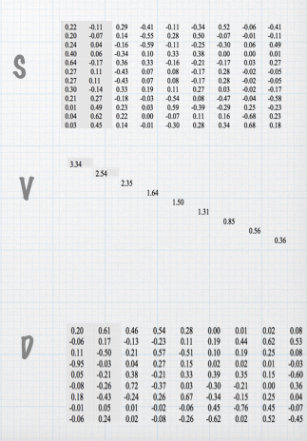

4. Get similarities between entities

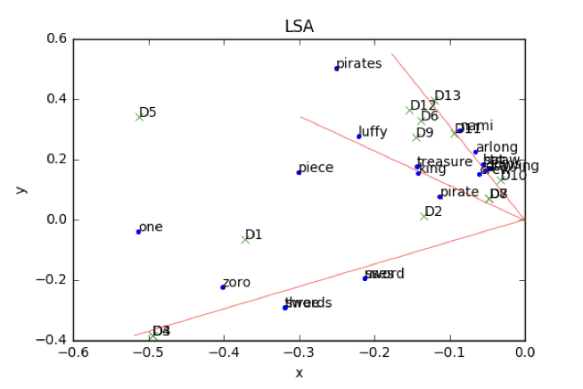

## Page Rank introduction

Given a set of nodes and the relationships between these nodes, PageRank provides us with a means of identifying which amongst these nodes is the most prestigious. Over time this notion of “prestige” has been adapted for many purposes, and along with that, been given many different names — “influence”, “importance”, etc.

Our interest here is in a rather niche implementation of PageRank which has significant consequences. We’re interested in how PageRank can be adapted to summarize text documents. That is, given a large collection of n sentences, how does one come up with an automated procedure for generating a summary of m sentences, where m < n. Naturally, to find those m sentences which are the most “important” from those n sentence is our goal.

**PR**

Sentences are regarded as nodes in the graph, while similarities among the sentences are regarded as edges between these nodes. When node B is connected with node A, this means that node B has voted for node A. Meanwhile, the vote is represented by the similarity between the nodes. The more similar node B is to node A, the more important the vote is from node B to node A. Additionally a node with a higher score will give a more authoritative vote. When a node gets many votes, this means the node is very important and will have a higher score.

By this way we can find the most several sentences in the given document.

**Simplified algorithm**

Assume a small universe of four web pages: A, B, C and D. Links from a page to itself, or multiple outbound links from one single page to another single page, are ignored. PageRank is initialized to the same value for all pages. In the original form of PageRank, the sum of PageRank over all pages was the total number of pages on the web at that time, so each page in this example would have an initial PageRank of 1. However, later versions of PageRank, and the remainder of this section, assume a probability distribution between 0 and 1. Hence the initial value for each page is 0.25.

The PageRank transferred from a given page to the targets of its outbound links upon the next iteration is divided equally among all outbound links.

If the only links in the system were from pages B, C, and D to A, each link would transfer 0.25 PageRank to A upon the next iteration, for a total of 0.75.



Suppose instead that page B had a link to pages C and A, page C had a link to page A, and page D had links to all three pages. Thus, upon the next iteration, page B would transfer half of its existing value, or 0.125, to page A and the other half, or 0.125, to page C. Page C would transfer all of its existing value, 0.25, to the only page it links to,A. Since D had three outbound links, it would transfer one third of its existing value, or approximately 0.083, to A. At the completion of this iteration, page A will have a PageRank of 0.458.

In other words, the PageRank conferred by an outbound link is equal to the document's own PageRank score divided by the number of outbound links L ().

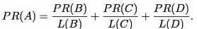

In the general case, the PageRank value for any page u can be expressed as:

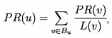

i.e. the PageRank value for a page u is dependent on the PageRank values for each page v contained in the set B (the set containing all pages linking to page u), divided by the number L(v) of links from page v.

**TextRank algorithm**

PageRank can be improved by TextRank, by adding a weight to the edge, namely the TextRank weighted graph model. In the TextRank model, the importance of a node is related to the number of votes it obtains, the importance of nodes voting it and similarity between them.

According to the above theory, we can describe the text as a weighted graph *G*= (*V, E*), where *V*is the set of nodes and *E*is the set of edges with *V*\**V*. The importance of node *Vi*is then defined by Equation (1):

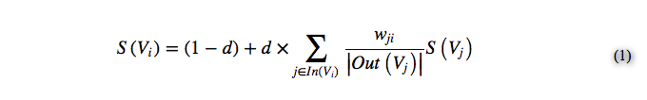

## Implement Setup and Procedure

First, we study the open text summarization available from the toolkits PyTLDR. It is an open text summarization with two scoring techniques LSA and TR. One is based on PageRank algorithm and the second is based on Latent Semantic Analysis. They use extraction based summarization where the sentences are scored and the highly scored sentences are included in the summarizer. We checked that the program using both html documents as input, as well as several text files. We also implemented another toolkits Sumy, it is with larger number of summarization approaches implemented.

The implemented code is shown as below:

* + 1. ***LSA***

The summarizer type selecting step:



* + 1. ***PageRank/TextRank***

The summarizer type selecting step:



* + 1. ***Sentence selection***

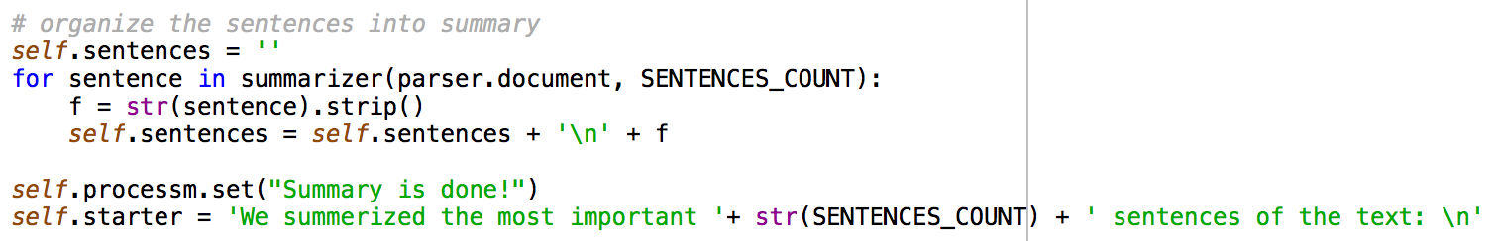

Above is the implementation of LSA and TR methods, the result and analysis will be given in Chapter 7.

# TEXTUAL SUMMARIZATION WITH NER

The purpose of this chapter is to present the how the Named Entities Recognition is implemented.

As we have already implemented LSA and TR in chapter 3, here we extend the above summarization by incorporating coherence of text with respect to named-entity. For this purpose, first, we utilize the LSA and TR methods to select the highly scored sentences from the given text and identify the named-entities that occurred in these highly scored sentence. Second, we identify appropriate named-entity recognizer script, here we used NER toolkits from NLTK. Next, we propose a methodology that outputs sentences where each of these named-entities occur. We also score the sentence in case there are a lot of such sentences beyond the limit of the summarizer.

## Named Entities Recognition

Named entities are definite noun phrases that refer to specific types of individuals. And Named Entity Recognition (NER) is to label sequences of words in a text which are the names of things, such as person and company names, or gene and protein names.

So, here our goal is to summary the text that mentions the named entities.

## Implementation with NLTK

We begin the NER implementation by considering the task of noun phrase chunking, or NP-chunking, where we search for chunks corresponding to individual noun phrases.

NP-chunks are often smaller pieces than complete noun phrases. NP-chunks are defined so as not to contain other NP-chunks. Consequently, any prepositional phrases or subordinate clauses that modify a nominal will not be included in the corresponding NP-chunk, since they almost certainly contain further noun phrases.

One of the most useful sources of information for NP-chunking is part-of-speech tags. This is one of the motivations for performing part-of-speech tagging in our information extraction system. We utilize this approach with an example sentence that has been part-of-speech tagged. In order to create an NP-chunker, we will first define a chunk grammar, consisting of rules that indicate how sentences should be chunked. In this case, we will define a simple grammar with a single regular-expression rule. This rule says that an NP chunk should be formed whenever the chunker finds an optional determiner (DT) followed by any number of adjectives (JJ) and then a noun (NN). Using this grammar, we create a chunk parser, and test it on our example sentence. The result is a tree, which we can either print, or display graphically.

And we will get the structures of the sentences like this:



by incorporating coherence of text with respect to named-entity. For this purpose, first, we utilize the LSA and TR methods to select the highly scored sentences from the given text and identify the named-entities that occurred in these highly scored sentence. Second, we identify appropriate named-entity recognizer script, here we used NER toolkits from NLTK. Next, we propose a methodology that outputs sentences where each of these named-entities occur. We also score the sentence in case there are a lot of such sentences beyond the limit of the summarizer.

## Implementation in Python

After we get a list of the named entities. We select the most frequent several ones and take them as the center topics of the given document. The give the summarization in Python like this:

1. list the candidate named entities:

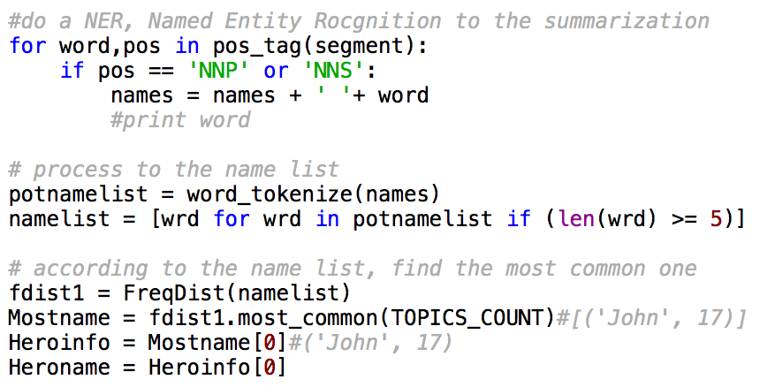

1. get the summarization:

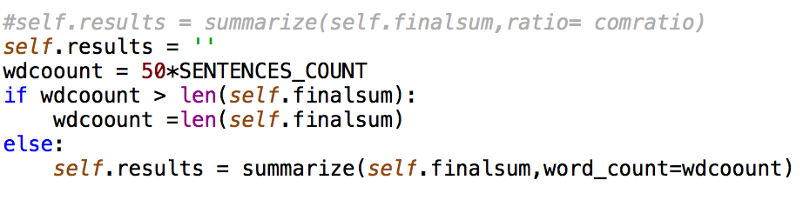

Above is the implementation of NER methods, the result and analysis will be given in Chapter 7.

# TEXTUAL SUMMARIZATION WITH RAKE

The purpose of this chapter is to present the procedure of summary method using RAKE. Method overviews and details for RAKE summary are shown in the corresponding section below.

Here we will first introduce the key extraction which is the core idea of RAKE. A typical keywords extraction algorithm is then introduced. Moreover, we will introduce the implementation steps of the RAKE method.

## Keywords extraction

Extracting keywords is one of the most important tasks when working with text. Readers benefit from keywords because they can judge more quickly whether the text is worth reading. Website creators benefit from keywords because they can group similar content by its topics. Algorithm programmers benefit from keywords because they reduce the dimensionality of text to the most important features. And these are just some examples.

By definition, keywords describe the main topics expressed in a document. The terminology can get a little confusing, so the image below compares related tasks in terms of the source of terminology and number of topics selected per document.

In this section we will focus on two specific tasks:

* Extracting the most significant words and phrases that appear in given text
* Identifying a set of topics from a predefined vocabulary that match a given text

A couple of words for those interested in text categorization (also called text classification), another popular task when working with text: if the number of categories is very large, we will struggle to collect enough training data for supervised classification. So, if we have 100 or more categories, and we can name these categories (they are not abstract), we are dealing with fine-grained categorization. We can treat this task as keyword extraction with a controlled vocabulary, or term assignment.

## Keywords extraction algorithm

A typical keyword extraction algorithm has three main components:

* Candidate selection: Here, we extract all possible words, phrases, terms or concepts (depending on the task) that can potentially be keywords.
* Properties calculation: For each candidate, we need to calculate properties that indicate that it may be a keyword. For example, a candidate appearing in the title of a book is a likely keyword.
* Scoring and selecting keywords: All candidates can be scored by either combining the properties into a formula, or using a machine learning technique to determine probability of a candidate being a keyword. A score or probability threshold, or a limit on the number of keywords is then used to select the final set of keywords.

Finally, parameters such as the minimum frequency of a candidate, its minimum and maximum length in words, or the stemmer used to normalize the candidates help tweak the algorithm’s performance to a specific dataset.

## Keyword extraction with Python using RAKE

The RAKE algorithm is described in the book Text Mining Applications and Theory by Michael W Berry ([amazon](https://www.amazon.com/Text-Mining-Applications-Michael-Berry/dp/0470749822/), [wiley.com](http://onlinelibrary.wiley.com/book/10.1002/9780470689646)):

1. Candidates are extracted from the text by finding strings of words that do not include phrase delimiters or stop words (a, the, of, etc). This produces the list of candidate keywords/phrases.

2. A Co-occurrence graph is built to identify the frequency that words are associated together in those phrases. Here is a good outline of how co-occurence graphs are built: [Mining Twitter Data with Python (Part 4: Rugby and Term Co-occurrences)](https://marcobonzanini.com/2015/03/23/mining-twitter-data-with-python-part-4-rugby-and-term-co-occurrences/)

3. A score is calculated for each phrase that is the sum of the individual word’s scores from the co-occurrence graph. An individual word score is calculated as the degree (number of times it appears + number of additional words it appears with) of a word divided by it’s frequency (number of times it appears), which weights towards longer phrases.

4. Adjoining keywords are included if they occur more than twice in the document and score high enough. An adjoining keyword is two keyword phrases with a stop word between them.

5. The top T keywords are then extracted from the content, where T is 1/3rd of the number of words in the graph

The implementation we used is based on [python-rake](https://pypi.python.org/pypi/python-rake/1.0.5), with some modifications for providing custom thresholds based on [this post](https://www.airpair.com/nlp/keyword-extraction-tutorial).

## Implementation RAKE in Python

After implementing RAKE algorithm, therefore, we can get a number of highly scored keywords, and we will choose the top N keywords, N can be decided by in the application, and select only those sentences which are highly scored and contain one of the above keywords. The implemented algorithm to achieve this task is shown below. The provide testing result on same example as in previous case will be shown in Chapter 7:

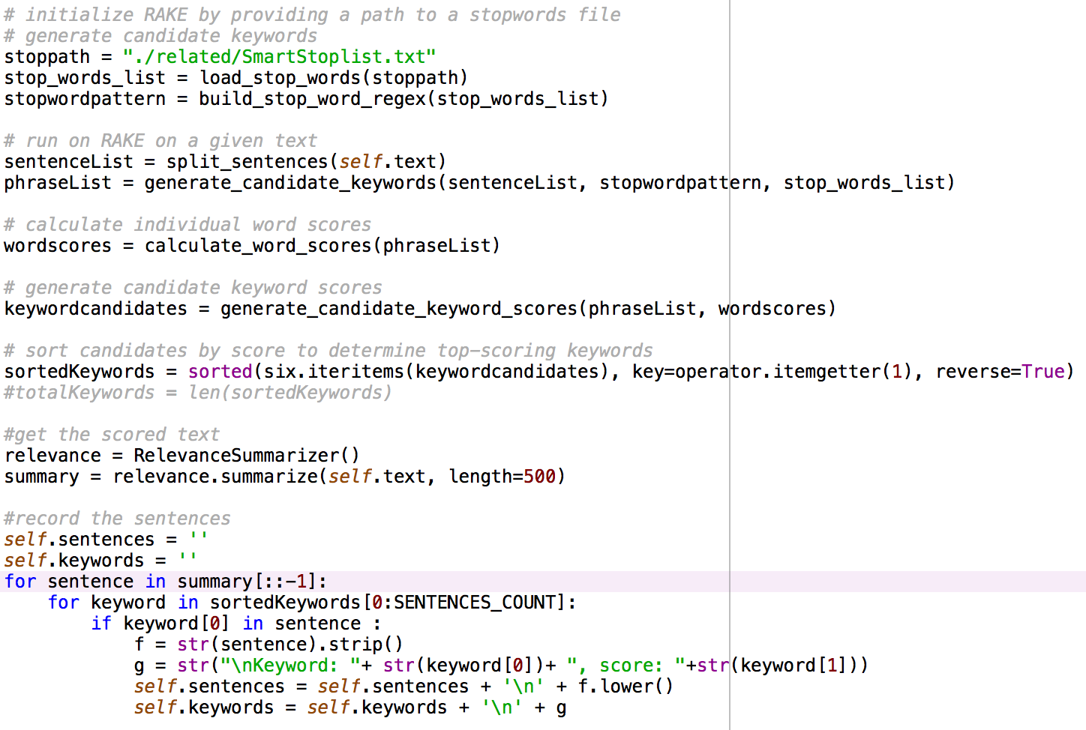

Above is the implementation of RAKE methods, the result and analysis will be given in Chapter 7.

# A summarizer Application

In this chapter, the implementation of the summarizer application process is illustrated. The UI design methods will be introduced. The textual processing details are demonstrated. The functional realization steps for multi-language recognition, website sparse and real-time image searching will be illustrated respectively.

## UI design

In this section, we will illustrate the UI design step, first, we give our initial flow char of the UI for the application:

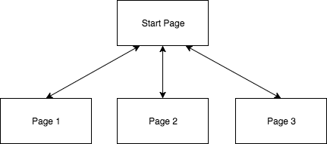

And then, we use a Python UI library called Tkinter to develop the application.

**Tkinter**

Tkinter is a Python binding to the Tk GUI toolkit. It is the standard Python interface to the Tk GUI toolkit, [1] and is Python's de facto standard GUI. [2] Tkinter is included with the standard Microsoft Windows and Mac OS X install of Python.

The name Tkinter comes from Tk interface. Tkinter was written by Fredrik Lundh. [3]

As with most other modern Tk bindings, Tkinter is implemented as a Python wrapper around a complete Tcl interpreter embedded in the Python interpreter. Tkinter calls are translated into Tcl commands which are fed to this embedded interpreter, thus making it possible to mix Python and Tcl in a single application.

**Tkinter UI design**

For each page, we design the UI separately. To make the user interface more friendly, we insert several Pokémon images to make it nicer.

For the start page, it can navigate users to the three summarizers. Each button will trigger one summarizer for LSA/PR, NER and RAKE respectively. We design it as below:

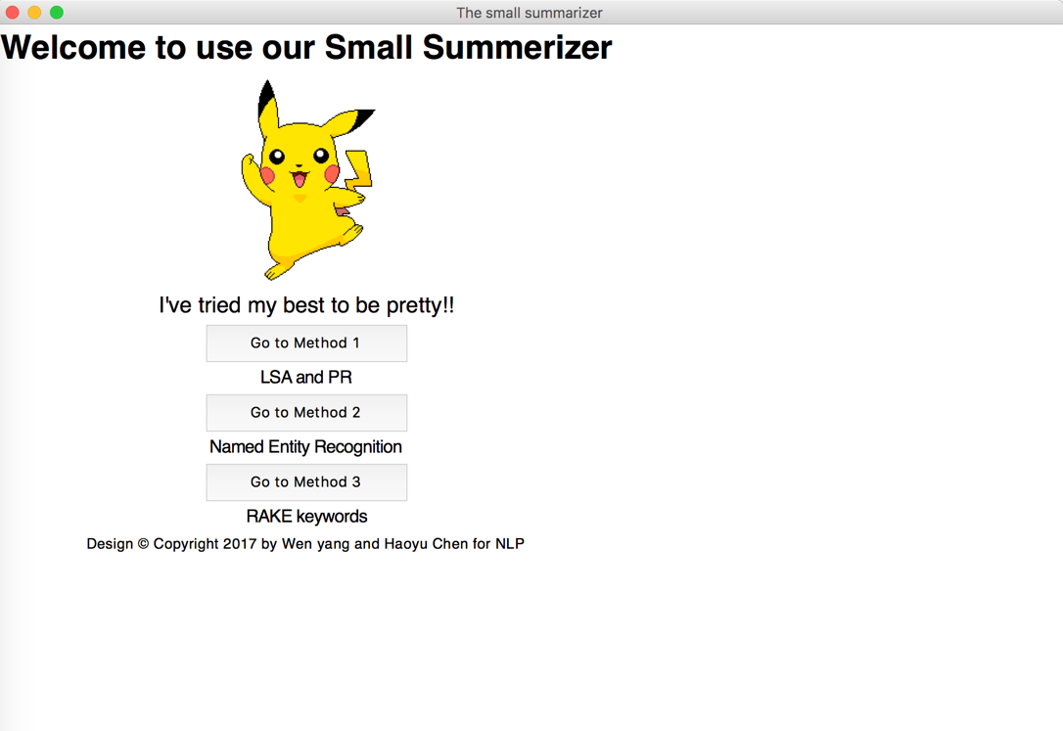

For the Page 1, it can guide use to use summarizer of LSA/PR to do a summarizer to a local document or the content from the website directly with Latent Sematic Analysis/Page Rank methods.

It has several options for user to choose. For the text to summarize, there are text language selection, summary sentence number selection, local file selection and website link input for user to handle. For the reference text to evaluate the summary result, there are N-gram number selection and local file selection for user to choose. And there is also a text window to display the summarized result, as well as the evaluate score result.

We design the Page 1 as below:

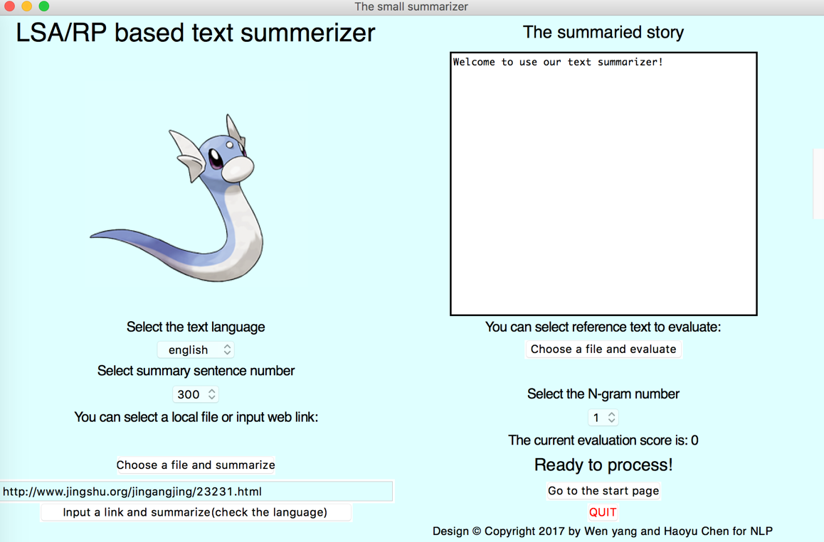

For the Page 2, it can guide use to use summarizer of NER to do a summarizer to a local document or the content from the website directly with Name Entities Recognition method.

It has several options for user to choose. For the text to summarize, there are text topic number selection, summary sentence number selection, local file selection and website link input column for user to handle. For the reference text to evaluate the summary result, there are also N-gram number selection and local file selection for user to choose. And there is also a text window to display the summarized result, as well as the evaluate score result.Besides, the NER method can summarize the central topics of the given document.

We design the Page 2 as below:

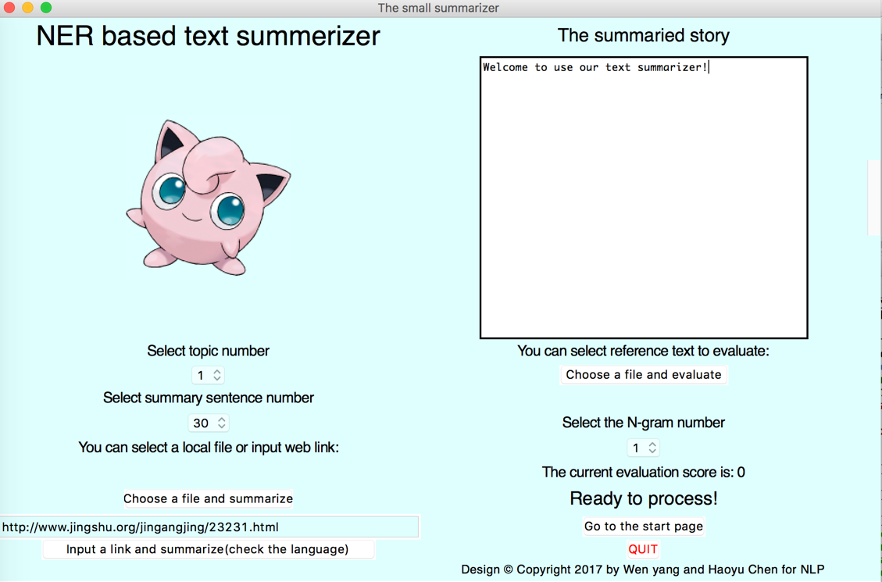

If we input the story of “Alice in wonderland”, it can summary the Heroine of the story as Alice, and display the image of Alice which is searched by Google on realtime. the summarize result will be below:

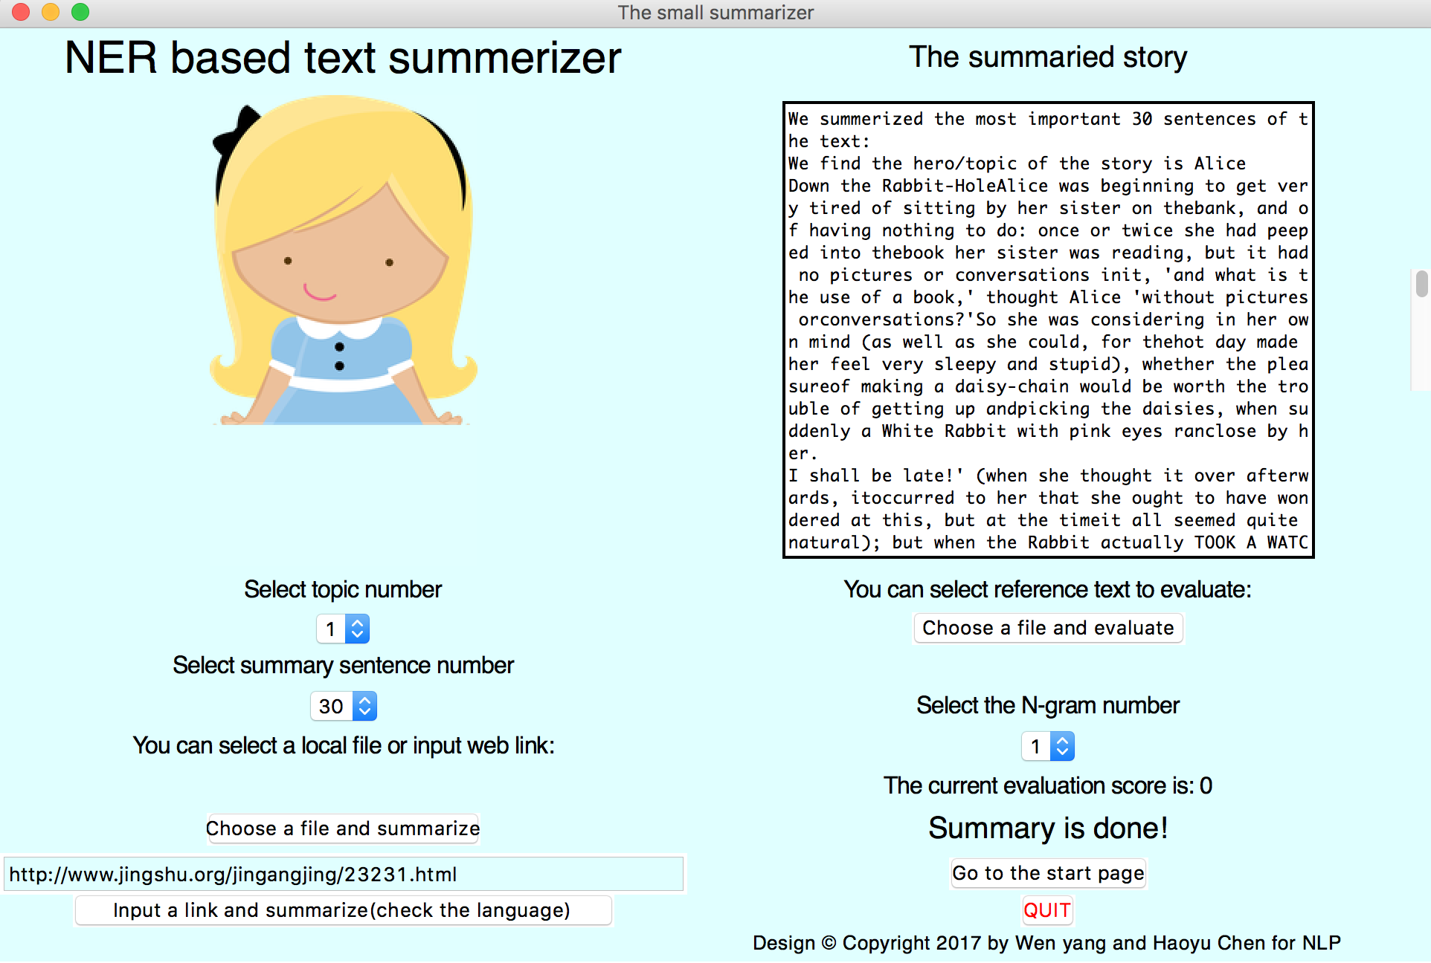

For the Page 3, it can guide use to use summarizer of RAKE to do a summarizer to a local document or the content from the website directly with Rapid Automatic Keyword Extraction method.

It has several options for user to choose. For the text to summarize, there are text topic number selection, summary sentence number selection, local file selection and website link input column for user to handle. For the reference text to evaluate the summary result, there are also N-gram number selection and local file selection for user to choose. And there is also a text window to display the summarized result, as well as the evaluate score result. Besides, the RAKE method will list the most important terms in the given document.

We design the Page 3 as below:

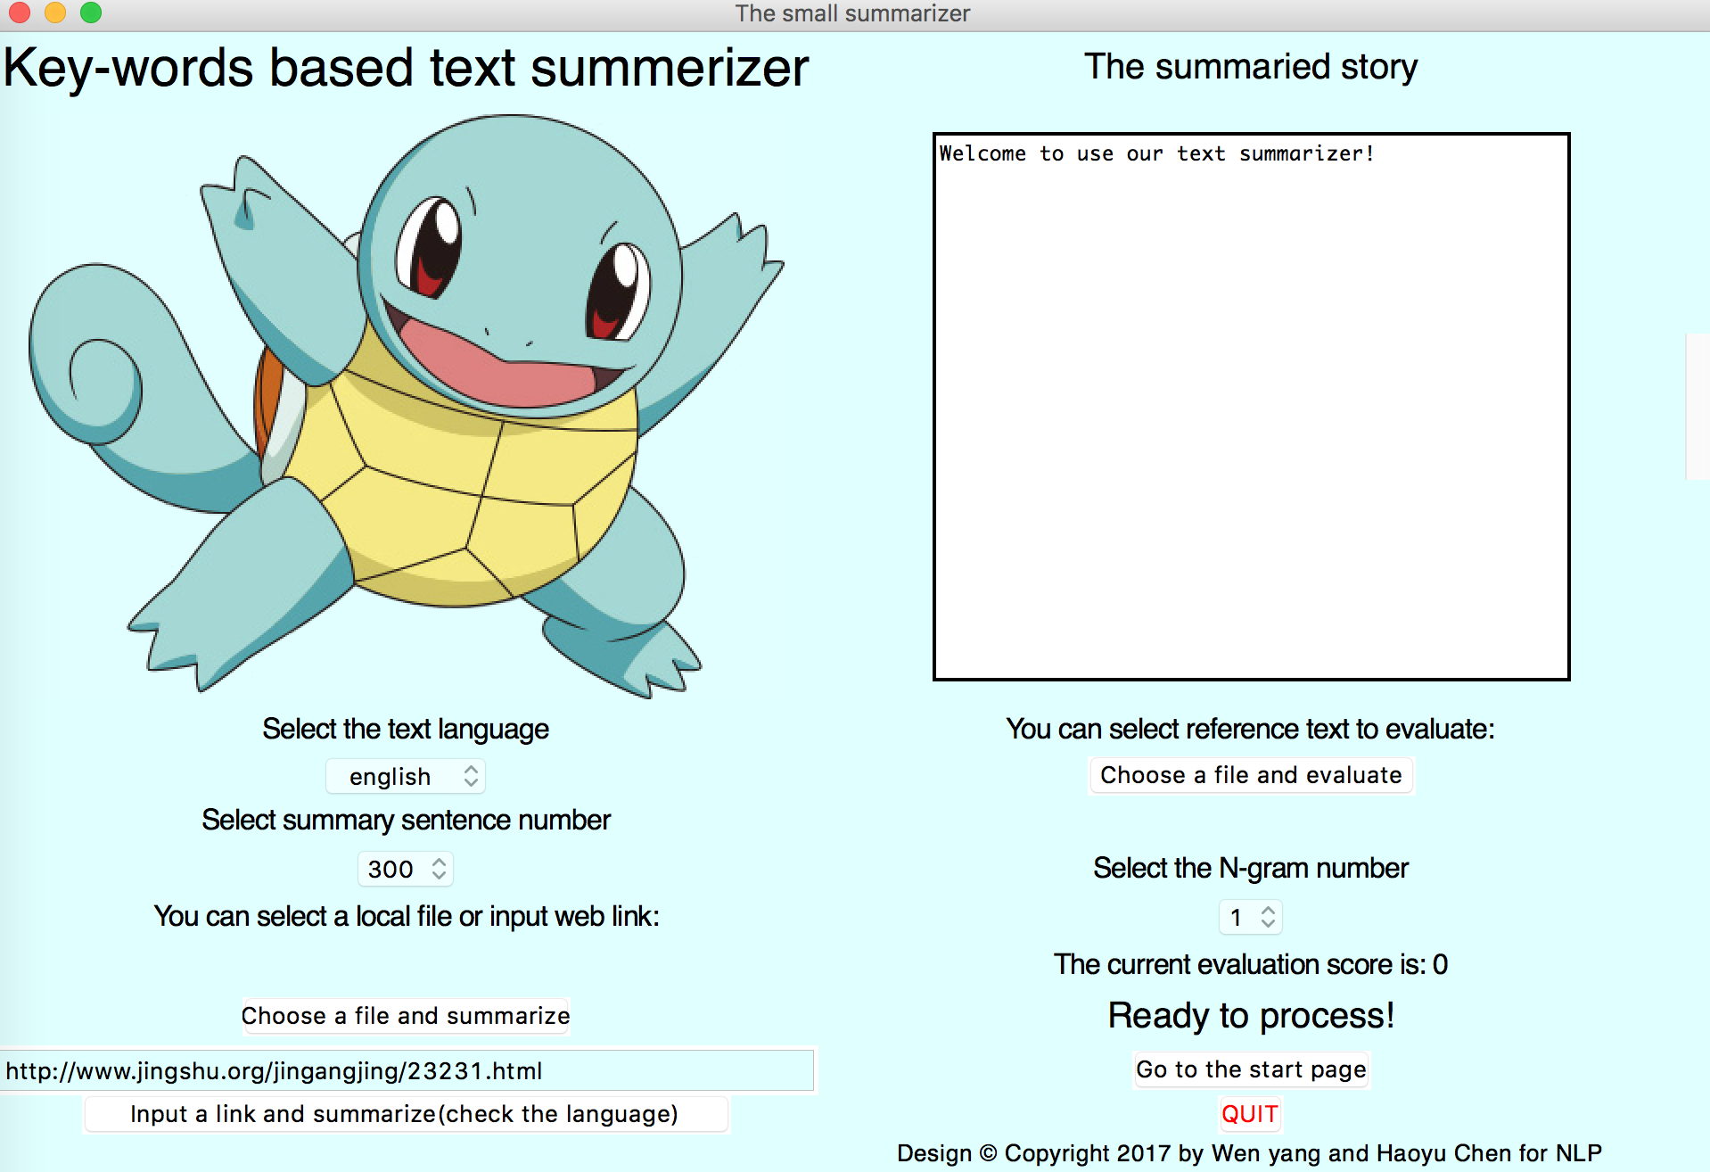

## Textual process

In this section, we will illustrate the detailed implementing steps of Automatic Text Summarization. ATS is a data mining process, which work towards obtaining a short version of a document, which conveys most content as that of the original document. The steps involved in text summarization are similar to that of any data mining procedure. As discussed in previous chapter, there are 40 emails threads in corpus with an average of 11 emails per thread. The initial step of this thesis is to parse the xml document in which 40 email threads are embed. Python and related APIs (such as NLTK) are used to get the data into the program. The tasks in this process can be categorized broadly as three phases. They are

• Pre-Processing,

• Feature Selection and Sentence Ranking

* + 1. ***Pre-Processing***

Pre-Processing is the first step in a data mining process. The idea of this step to take the unstructured data and make it structured so that it can be processed. Unstructured data can have missing values, bad values or anything that can lead to unwanted results. Data Pre-Processing helps in getting data clean and ready for processing. In text summarization, pre-processing is a step where the document is parsed and important words are identified leaving behind stop-words and other unrelated stuff from documents. The main steps of pre-processing are:

• Sentence Segmentation

• Case Folding

• String Tokenization

• Stop-Word Removal

• Stemming

**Sentence Segmentation**

Input document is divided into sentences. The end of sentence is identified by punctuation marks. A Regular expression is used to split the document into sentences. This regular expression is constructed in a way to identify all punctuation marks that could end a sentence.

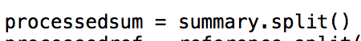

**Case Folding**

The sentences, which are divided from text documents, are taken as the input for case folding. Case folding is a process of converting text into either Upper case or to lower 14 case. Though this step might be trivial, it ensures there won’t be any wrong calculations in ranking words due to different case issues.



**String Tokenization**

Once the case folding is done, sentences undergo string tokenization. It is the process of breaking a sentence into words, phrases or any meaningful elements. These meaningful elements are called tokens. These tokens are then processed through text mining or feature selection step.



**Stop – Words Removal.**

Stop – Words are very common in documents and occur in majority of documents. Stop – words don’t provide any semantic information. Most stop-words are related to language such as article, auxiliary verbs etc. If dealing with a small document, stop –words won’t be a problem but when dealing with a large sized document or multi- document summarization, removing stop – words would help in reducing space and time complexities. As stop – words really don’t provide any information at word level, removing stop – words tokens would help in normalizing the word ranks.



**Stemming**

Stemming is a process identifying the root word from its other from like past tense word, future tense word etc. For example, work, works, working, worked come from the root word of word. While ranking the words, assigning different rank to each of above words 15 will diverse the importance of word work in the whole document. Instead if stemming is applied on above words and rank is assigned to the root word work will help in increasing the weightage of word work in document irrespective of its grammar.

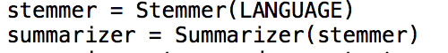

* + 1. ***Feature selection and sentence ranking***

Once the pre-processing is done, we obtain at list of terms that are significant to the documents. Features that help in identifying importance sentences are applied on these words and subsequently words and sentences are ranked. How sentences are ranked using these feature metrics is given in the above three chapters 3,4,5 for LSA/PR, NER and RAKE respectively.

## Function utilities

In this section, we will illustrate the detailed realization steps of the two functions we achieved in our application. They are multi-language recognition, website content sparse and real-time topic display.

* + 1. ***Multi-language recognition***

Here we introduce how we process documents with Chinese language that contains special characters for natural language processing and summarization. The concept of "plain text" is a fiction. If we live in the English-speaking world we probably just use ASCII, possibly without realizing it. If we live in Chinese we should use extended character sets, containing such characters as ‘你’. In this section, we will give a brief explanation of how we use Unicode for processing texts that use non-ASCII character sets.

**What is Unicode?**

Unicode supports over a million characters. Each character is assigned a number, called a code point. In Python, code points are written in the form \uXXXX, where XXXX is the number in 4-digit hexadecimal form.

Within a program, we can manipulate Unicode strings just like normal strings. However, when Unicode characters are stored in files or displayed on a terminal, they must be encoded as a stream of bytes. Some encodings (such as ASCII and Latin-2) use a single byte per code point, so they can only support a small subset of Unicode, enough for a single language. Other encodings (such as UTF-8) use multiple bytes and can represent the full range of Unicode characters.

For Chinese, the standard UTF-8 is always used.

Text in files will be in a particular encoding, so we need some mechanism for translating it into Unicode — translation into Unicode is called decoding. Conversely, to write out Unicode to a file or a terminal, we first need to translate it into a suitable encoding — this translation out of Unicode is called encoding.

From a Unicode perspective, characters are abstract entities which can be realized as one or more glyphs. Only glyphs can appear on a screen or be printed on paper. A font is a mapping from characters to glyphs.

The decode method is given below:

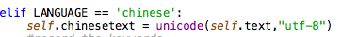

After we decode the given document with UTF-8, we can process the given document with stop-words and stemming:

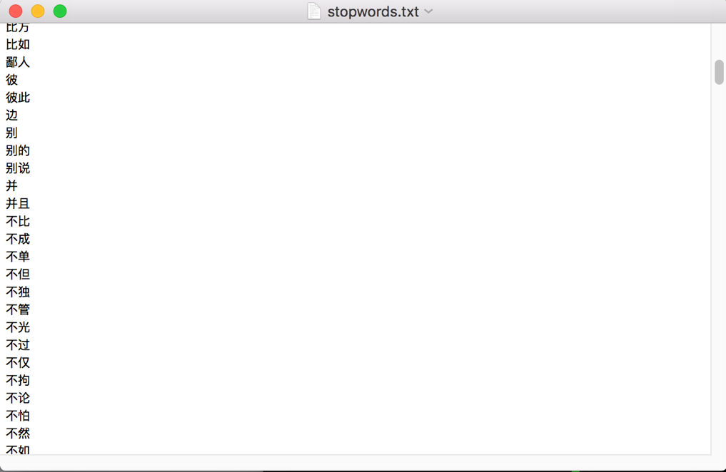

After the Chinese characters is processed, we will regenerate the character string by:

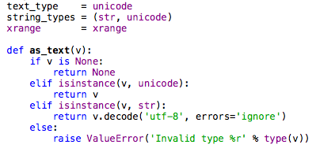

That’s all for the procedures to process the non-ASCII contexts.

* + 1. ***Website content sparse***

Here we introduce how we process textual content online for natural language processing and summarization. It contains website textual content extraction and analysis.

**Website textual content extraction**

First, we utilize the URL offered by user to extract the respond content of the whole website:

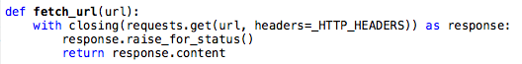

**Website textual content analysis**

Then, we sparse the content by removing the ‘pre’ and generate the complete text:

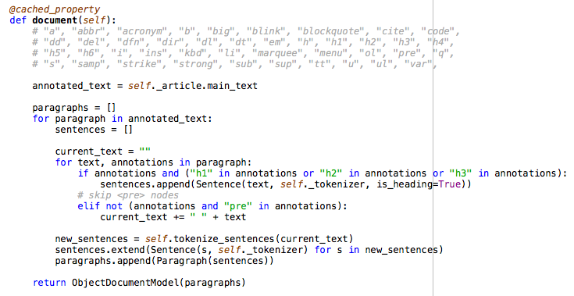

At last, we process the content as normal document by using summary methods such LSA, NER to generate the final result.

* + 1. ***Real-time Topic display***

Here we introduce how we display an image that is related to the central topic of the given document. The procedures include two steps: 1. central topic generating, 2. keywords searching on Google, 3. image process and display.

**Central topic generating**

As we can get the list of named entities from the given file, we can select the most important term as the central topic of the given doc. The process is shown below:

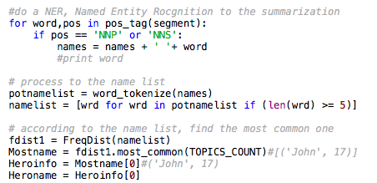

**keywords searching on Google**

After we get the central topic of the given doc, we can use this term as the search keyword to find the related images on Google. To make the result images more acceptable, we also add another keyword, ’cute’. The process is shown below:

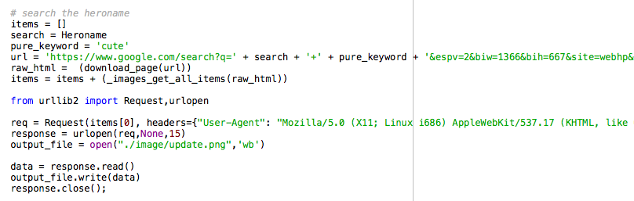

**Image process and display**

At last, when we get the related images on Google, we download and resize the image to suit our application interface. And the window is the updated with the new image. The process is shown below:

Resize:

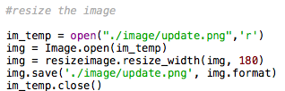

Update:

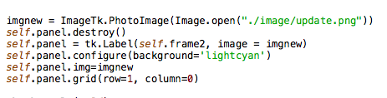

That’s all for the procedures to display the topic related image.

# EXPERIMENTAL RESULTS AND DISCUSSION

In this chapter, the test experiment is done on the DUC2003 dataset, and the result is illustrated. The experimental results will be analyzed and discussed also.

## Experiments

In this section, we will illustrate the detailed experimental steps the three summarizers. Before the experiment, we first introduce the dataset we used, as well as its reference document. Then, we will display the experiment results.

The project code for the final work can be found at:

<https://github.com/mikecheninoulu/A-cute-Summerizer->

* + 1. ***DUC 2003 Corpus***

DUC 2003 uses documents from the TDT and TREC collections and will incorporate focus of various sorts to reduce variability and better model real tasks. It will examine automatic creation of short and very short summaries. What follows is a brief description of the data and tasks - a more detailed version of what was developed at the DUC 2002 Workshop.

**30 TREC document clusters**

Documents/clusters: NIST assessors will choose 30 clusters of TREC documents related to subjects of interest to them. Each subset will contain on average 10 documents.

The documents will come from the following collections with their own taggings:

* AP newswire, 1998-2000
* New York Times newswire, 1998-2000
* Xinhua News Agency (English version), 1996-2000

Manual summaries: NIST assessors will create a very short summary (~10 words, no specific format other than linear) of each document. They will also create a focused short summary (~100 words) of each cluster, designed to reflect a viewpoint defined by the assessor.

**30 TDT document clusters**

Documents/clusters: NIST staff will choose 30 TDT topics/events/timespans and a subset of the documents TDT annotators found for each topic/event/timespan. Each subset will contain on average 10 documents. The documents will come from the same collections identified above.

Manual summaries: NIST assessors will be given the TDT topic and will create a very short summary (~10 words, no specific format other than linear) of each document and a short summary of each cluster. These summaries will not be focused in any particular way beyond by the documents and the topic.

**30 TREC Novelty track document clusters**

Documents/clusters: NIST staff will choose 30 TREC Novelty Track question topics and a subset of the documents TREC assessors found relevant to each topic. Each subset will contain on average 22 documents.

The documents will come from the following collections with their own taggings:

* Financial Times of London, 1991-1994
* Federal Register, 1994
* FBIS, 1996
* Los Angeles Times 1989-1990
* Here are the DTDs.

Manual summaries: NIST assessors will create a focused short summary (~100 words) of each cluster, designed to answer the question posed by the TREC topic.

So, overall, it has 22,071 words, 865 sentences for us to test the summarizers’ performance.

## Evaluation Methods

Unlike other problems in computer science, there is no gold-standard evaluation method for summarization. The goal is to be obtaining at a summary, which is very similar to human generated summary. As different authors have their unique way of writing and understanding, reaching at a gold standard summary standard has been difficult. Within extractive and abstractive methods of summarization, evaluation of extractive based summarization is kind of fruitful as the process involves selection of sentences within the document, whereas, in abstractive-based summarization, generated summary should be compared with human written summary through re-phrasing the sentences in the document. Here we will use N-ROUGE method to evaluate the result.

**N-ROUGE**

ROUGE (Recall-Oriented Understudy for Gusting Evaluation) is most commonly used evaluation technique. This method relies on recall-based evaluation. The generated method will be compared with human generated summary for recall measure.

ROUGE-N: Overlap of N-grams[[3]](https://en.wikipedia.org/wiki/ROUGE_(metric)#cite_note-3) between the system and reference summaries.

* ROUGE-1 refers to the overlap of 1-gram (each word) between the system and reference summaries.
* ROUGE-2 refers to the overlap of bigrams between the system and reference summaries.

Recall means how much information it collects:

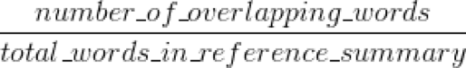

Precision means: how much information it collected is valuable

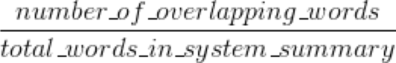

## Experimental Results

The test dataset is introduced above as DUC 2003, here we introduce the experiment result of our summarizers, LSA/PR, NER, RAKE respectively.

Our first experiment tests the performance of the LSA summarizer on DUC 2003 dataset by changing sentence number of the summary result. The performance is averaged by result of 1-gram and 2-gram.

The result of LSA summarizer

|  |  |  |  |  |  |  |  |  |  |
| --- | --- | --- | --- | --- | --- | --- | --- | --- | --- |
| **Sentence number** | **30** | | | **150** | | | **300** | | |
| **Results** | **recall** | **precision** | **F1** | **recall** | **precision** | **F1** | **recall** | **precision** | **F1** |
| **1-gram** | **59 %** | **29 %** | **38.9%** | **64 %** | **32 %** | **40.4%** | **60 %** | **30 %** | **40%** |
| **2-gram** | **8 %** | **4 %** | **5.3%** | **10 %** | **5 %** | **6.2%** | **9 %** | **5 %** | **6.4%** |
| **average** | **33 %** | **17 %** | **22.1%** | **37 %** | **19 %** | **23.3%** | **35 %** | **17 %** | **22.6%** |

Then, we test the performance of the PR summarizer on DUC 2003 dataset also by changing sentence number of the summary result. The performance is averaged by result of 1-gram and 2-gram and the results is shown below.

The result of PR summarizer

|  |  |  |  |  |  |  |  |  |  |
| --- | --- | --- | --- | --- | --- | --- | --- | --- | --- |
| **Sentence number** | **30** | | | **150** | | | **300** | | |
| **Results** | **recall** | **precision** | **F1** | **recall** | **precision** | **F1** | **recall** | **precision** | **F1** |
| **1-gram** | **59 %** | **27 %** | **37.9%** | **62 %** | **30 %** | **40.4%** | **58 %** | **29 %** | **38.7%** |
| **2-gram** | **7 %** | **4 %** | **4.9%** | **8 %** | **5 %** | **6.2%** | **9 %** | **5 %** | **6.4%** |
| **average** | **33 %** | **16 %** | **23.4%** | **35 %** | **18 %** | **23.3%** | **33 %** | **17 %** | **22.6%** |

In the experiment for NER, we test the performance of NER summarizer on DUC 2003 dataset by changing sentence number of the summary result in the same way. The performance is also averaged by result of 1-gram and 2-gram and the results is shown below.

The result of NER summarizer

|  |  |  |  |  |  |  |  |  |  |
| --- | --- | --- | --- | --- | --- | --- | --- | --- | --- |
| **Sentence number** | **30** | | | **150** | | | **300** | | |
| **Results** | **recall** | **precision** | **F1** | **recall** | **precision** | **F1** | **recall** | **precision** | **F1** |
| **1-gram** | **60.5%** | **30 %** | **40.1%** | **61.3%** | **30.7%** | **40.9%** | **63 %** | **31.4%** | **41.9%** |
| **2-gram** | **13 %** | **6 %** | **8.2%** | **12 %** | **6 %** | **8%** | **11 %** | **6 %** | **7.8%** |
| **average** | **37 %** | **18 %** | **24.2%** | **37 %** | **19 %** | **24.5%** | **37 %** | **19 %** | **25.1%** |

In the experiment for RAKE, we test the performance of RAKE summarizer on DUC 2003 dataset by changing sentence number of the summary result in the same way. The performance is also averaged by result of 1-gram and 2-gram and the results is shown below.

The result of RAKE summarizer

|  |  |  |  |  |  |  |  |  |  |
| --- | --- | --- | --- | --- | --- | --- | --- | --- | --- |
| **Sentence number** | **30** | | | **150** | | | **300** | | |
| **Results** | **recall** | **precision** | **F1** | **recall** | **precision** | **F1** | **recall** | **precision** | **F1** |
| **1-gram** | **61.8%** | **30 %** | **40.4%** | **61.3%** | **30.7%** | **40.9%** | **62 %** | **31 %** | **41.3%** |
| **2-gram** | **13 %** | **6 %** | **8.2%** | **11 %** | **5 %** | **6.9%** | **10 %** | **5 %** | **6.7%** |
| **average** | **37 %** | **18 %** | **24.3%** | **36 %** | **18 %** | **23.9%** | **36 %** | **18 %** | **24%** |

The analysis of these performances will be done in the next section. To make it clear, we plot the line grams of the result as following. We separate the performance of these three summarizers by the N-gram number.

First, we plot the summarizer comparison of 1-gram:



Then, we plot the performances of these summarizers on 2-gram:



At last, we plot the average performances of these four summarizers, we get:



## Results Analysis and Discussion

Based on the experimental results above, the analysis is given here with the performance of the corresponding summarizers.

Here we represent three comparison experiments for the summarizers. In the first experiment, 1-gram is used to evaluate the result, and we can find that NER and RAKE performance better than the LSA and PR.

The second graph, it shows that NER and RAKE still performance better than that of LSA and PR, but the differences between the results are not much. The trends show that this difference will become smaller when document size is larger. Note that there is a huge drop of the performance when the gram number changes from 1 to 2, because we just use the whole sentences to form the summary content in LSA and PR. It can be seen that NER performance better because it uses compressed sentences to generate the results.

In the third experiment, the average performances of there four methods are tested. Obviously, NER performances the best, followed by RAKE. This is reasonable as it is a combination of the performances of 1-gram and 2-gram.

Finally, we can conclude that, NER performance better among these summarizers.

# Conclusion

In this technical report, we have designed a summary application and illustrated the detailed procedures.

For the study of summarization, we have reviewed four different summarizers as LSA, PR, NER and RAKE. We give a detailed principle explanation of these summarizers, as well as their implementations in Python.

For the application of the project, we implemented three sets of summarizers for textual summary task with a user-frienfly UI design. Practical implementation of the DBN-HMM model is achieved. It can process skeleton joints data of a sample sequence. The process output is the segmentation and recognition of the micro-gestures in that sequence. Meanwhile, a multi-modal (fusing RGB and depth data) of the 3DCNN-HMM is also achieved for micro-gestures segmentation and recognition. These two methods are tested on our MG dataset.

Additionally, we explored a method as activity level detection for setting the neutral states in the HMM model. Commonly, the manual labeling neutral states method was used in designed gesture sequence. In this thesis, we try to utilize variance factor to learn the activity level of the gesture sequences. Then, the neutral states can be selected based on their activity levels. Although this neutral state extraction step is simple, it is effective in improving the experimental results.

We also presented the analysis of the experiments. Experimental result analysis of variety DBN-HMM structures is given with a different number of input samples. It is proved that few input samples with complex architectures will lead to an over-fitting problem. A comparison between the DBN-HMM and 3DCNN-HMM is given. The experimental results show that for the MG dataset, the DBN-HMM based approach is more suitable.

As future work, there are several directions. One is exploring different multi-modal architectures based on HMM, such as fusing the skeleton and RGB-D features from the DBN and 3DCNN architectures. Besides, a more regular labeling strategy should be set with a reliable micro-gesture classification. It is better to label the micro-gestures with a sufficient psychology fundamental. It would be more efficient for improving the recognition results and reasonable for future research. Another research path would be to improve the 3DCNN architecture with temporal information through the max pooling.

# REFERENCES

1. C. Xu & L. Cheng (2013) Efficient hand pose estimation from a single depth image. Proc. IEEE International Conference on Computer Vision: 3456-3462. DOI: [10.1109/ICCV.2013.429](https://doi.org/10.1109/ICCV.2013.429).
2. Y. Wang, T. Yu, L. Shi, & Z. Li (2008) Using human body gestures as inputs for gaming via depth analysis. Proc. 2008 IEEE International Conference on Multimedia and Expo: 993-996. DOI: [10.1109/ICME.2008.4607604](https://doi.org/10.1109/ICME.2008.4607604).
3. J. Alon, V. Athitsos, Q. Yuan, & S. Sclaroff (2009) A unified framework for gesture recognition and spatiotemporal gesture segmentation. Proc. IEEE Transactions on Pattern Analysis and Machine Intelligence 31(9): 1685-1699. DOI: [10.1109/TPAMI.2008.203](https://doi.org/10.1109/TPAMI.2008.203).
4. D. Wu, L. Pigou , P. J. Kindermans, N. Le & L. Shao (2016) Deep Dynamic Neural Networks for Multimodal Gesture Segmentation and Recognition. Proc. IEEE Transactions on Pattern Analysis and Machine Intelligence 38(8): 1583-1597. DOI: [10.1109/TPAMI.2016.2537340](https://doi.org/10.1109/TPAMI.2016.2537340).
5. E. Haggard & K. Isaacs (1966) Micromomentary facial expressions as indicators of ego mechanisms in psychotherapy. Methods of research in psychotherapy. New York: Appleton-Century-Crofts: 154-165.
6. Z. Zeng, M. Pantic, G. Roisman, & T. Huang (2009) A survey of affect recognition methods: Audio, visual, and spontaneous expressions. Proc. IEEE Transactions on Pattern Analysis and Machine Intelligence 31(1): 39-58. DOI: [10.1109/TPAMI.2008.52](https://doi.org/10.1109/TPAMI.2008.52).
7. Yang, M., Ahuja, N. (1998) Extraction and Classification of Visual Motion Patterns for Hand Gesture Recognition. Proc. 1998 IEEE Computer Society Conference on Computer Vision and Pattern Recognition. DOI: [10.1109/CVPR.1998.698710](https://doi.org/10.1109/CVPR.1998.698710).
8. Yang, J., Xu, Y., Chen, C. (1994) Gesture Interface: Modeling and Learning, Proc. IEEE International Conference on Robotics and Automation 2: 1747-1752. DOI: [10.1109/ROBOT.1994.351340](https://doi.org/10.1109/ROBOT.1994.351340).
9. N. Neverova, C. Wolf, G. Taylor, & F. Nebout (2014) Multi-scale deep learning for gesture detection and localization. Proc. 2014 European Conference on Computer Vision and Pattern Recognition Workshops: 474-490. DOI: 10.1007/978-3-319-16178-5_33.
10. S. Escalera, J. Gonzlez, X. Bar, M. Reyes, O. Lops, I. Guyon, V. Athitsos, & H. J. Escalante (2013) Multi-modal gesture recognition challenge 2013: Dataset and results. Proc. ACM ChaLearn Multi-Modal Gesture Recognition Grand Challenge and Workshop: 445-452. DOI: [10.1145/2522848.2532595](https://doi.org/10.1145/2522848.2532595).
11. J. Wang, Z. Liu, Y. Wu, & J. Yuan (2012) Mining actionlet ensemble for action recognition with depth cameras. Proc. IEEE Conference on Computer Vision and Pattern Recognition. DOI: [10.1109/CVPR.2012.6247813](https://doi.org/10.1109/CVPR.2012.6247813).
12. P. Ekman (2009) Lie catching and microexpressions. The philosophy of deception: 118-133. DOI:10.1093/acprof:oso/9780195327939.003.0008.
13. P. Ekman & M. O’Sullivan (1991) Who can catch a liar. American psychologist 46(9): 913-20.